Palingenesis Author Media Kit

Bios
Two-line Bio: An elder millennial, Tyerone Johnson is a native of Metro-Detroit who writes about complex LGBTQ+ people of color who save the world with panache.

Short bio: Tyerone Johnson is a thirtysomething bisexual, biracial male, who writes about complex LGBTQ+ people of color who save the day with panache from his suburban-Detroit home.
He fell in love with books at an early age,
and his debut novel Palingenesis follows a bullied boy who learns he’s evil’s chosen one.

Medium bio: Tyerone Johnson is a thirtysomething bisexual, biracial male, who writes about complex LGBTQ+ people of color who save the day with panache from his suburban-Detroit home.
He fell in love with books at an early age, and his debut novel Palingenesis follows a bullied boy who learns he’s evil’s chosen one.
The oldest of four children, he graduated high school 10th out of 180 students, with a 3.377 GPA, and is a member of the National Honor Society.
He later studied physics in college, before leaving to pursue writing.
He now writes full time and is working on the sequel.

Long Bio: Tyerone Johnson is an elder millennial bisexual, biracial male, who writes about complex LGBTQ+ people of color who save the day with panache from his suburban-Detroit home.
His father often read to him when he was a child, and he fell in love with books and stories. The oldest of four children, at six years old he suffered a severe allergic reaction to antibiotics that left him in the hospital for over a year. He lost over eighty percent of his epidermis, had his vocal cords accidentally severed, rending him effectively mute. Then he almost died when he developed an aneurysm in his right wrist following a procedure to sew an IV into the artery went wrong.
He later slipped into a coma for six months before regaining consciousness. Then he had to have an emergency tracheotomy when his airway collapsed. After weeks of physical therapy, he relearned how to walk and went home.
When he started school, kids often teased him due to his breathing tube and because of his raspy voice.
Writing became his primary form of communication and taught him the importance of words and the power they hold.
He focused on his schoolwork, reading, video games and graduated high school 10th out of 180 students, with a 3.377 GPA, and is a member of the National Honor Society.
Later he studied physics in college, before leaving to pursue writing.
As time passed. Tyerone found a lack of stories with queer people of color like him in them, so he set out to change that. After years of reading books on writing and many false starts, his debut novel Palingenesis, will release later this year. It follows a bullied boy who learns he’s evil’s chosen one and then must fight the devil to protect the world and boy he loves.
Tyerone now writes full time and is working on the sequel to Palingenesis. He also started a freelance writing and editing business to help fill the world with all the stories he wished were around when was younger.
It is his sincerest hope that after people read Palingenesis, they’ll find the inner strength to overcome their obstacles and rise above their circumstances like he has.

Speaker Introduction
The oldest of four kids, an ‘80s baby and ‘90s kid, Tyerone Johnson was raised on a steady diet of anime, comics, video games, b-horror and sci-fi movies, and more fantasy and sci-fi shows than he can name.
Hailing from Southeastern Michigan, he writes about complex people of color who save the day with panache. He also dabbles in poetry, essays, and think pieces.
When he was six, he had a severe allergic reaction to antibiotics that put him in the hospital for over a year and left him with a breathing tube and speech impairment due to his vocal cords being accidentally severed while he was in a six-month coma.
However, he doesn’t let this stop him from getting his message out.

Five Fun Facts You Didn’t Know About Me
- I can talk like Donald Duck
- I hate raw tomatoes, but love ketchup, tomato soup, and tomato pasta sauce.
- As a kid, I used to literally hide in the closet when my cousins and siblings had their birthday parties. (What a drama queen, right?)
- I have six tattoos
- I have French ancestry and am related to three genetic groups of French and French-Canadian fur traders and lumberjacks that settled along the St. Lawrence River.

Synopses
Two-line:
Palingenesis is about a bullied boy who learns he’s evil’s chosen one, yet does good.

Short:
Palingenesis is about twelve-year-old Travis Turner, and follows him as he learns he’s evil’s chosen one, destined to bring on the end of everything. Travis resists his destiny, and in the process awakens a great power within him that he uses to fight the devil and the forces of evil.

Medium:
Palingenesis is about twelve-year-old Travis Turner, and follows him as he learns he’s evil’s chosen one, destined to bring on the end of everything.
Travis resists his destiny, and in the process awakens a power within him that he uses to fight the devil and the forces of evil.
Along for the journey is Pro, an entity who resides in Travis’s mind. Pro tries to keep Travis from going to the dark side by setting him up with JJ Giovanni, a boy from school who has bullied Travis for years. As Travis’s powers intensify, so does his relationship with JJ.

Long: Palingenesis is about twelve-year-old Travis Turner, and follows him as he learns he’s evil’s chosen one, destined to bring on the end of everything.
Travis resists his destiny, and in the process awakens a power within him that he uses to fight the devil and the forces of evil.
Along for the journey is Pro, an entity who resides in Travis’s mind. Pro tries to keep Travis from going to the dark side by setting him up with JJ Giovanni, a boy from school who has bullied Travis for years. As Travis’s powers intensify, so does his relationship with JJ.
After Travis and JJ share an intimate moment together, JJ cracks a joke about Travis’s weight. Travis teleports home and the devil whispers into his ear to go train, leading to Travis losing control of his powers, and JJ revealing that he’s been stalking Travis for months before they got together.
Disgusted and angered at JJ’s betrayal, Travis regains memories of how his parents allowed the govern to experiment on him as a toddler. He seeks revenge against them, but Josh intervenes, and Travis attacks him.
Before they can reconcile, soldiers form the government arrive and attack Travis; he lays wastes to them, but not before they riddle his body with bullets. Just when it seems Travis is a goner, he’s called to a cave. There he learns truths about himself that forever change his life.
The following separates Palingenesis from other YA fantasy books:
- It has a queer person of person as the protagonist.
- It’s written by a queer person of color.
- It’s about evil’s chosen one instead of good’s chosen one, the latter of which is ubiquitous in Fantasy.
- It’s unapologetically queer, geeky, snarky, and intersectional.
- Unlike many male/male romances, in YA and other genres. Palingenesis isn’t written for the white, cis, het female gaze.
- It addresses the often confusing, messiness of first loves with unflinching honesty.
- While this is the first book in a series, readers can begin the series without fear of it never being completed, because the first draft of the series is complete.

Press Release

For Immediate Release
Tyerone Johnson
(947)414-0978
tyerone.johnson@tyeronejohnson.com
tyeronejohnson.com

Metro Detroit Author Triumphs Over Adversity, Pens Debut Novel

Pontiac, MI October 4, 2021— Tyerone Johnson, 37, of Pontiac, suffered a severe allergic reaction to penicillin (Stevens-Johnson syndrome) at age six that forever changed his life. He lost 80% of his epidermis, fell into a six-month coma, had to learn to walk again and needed the use of a breathing tube, which he still requires today.
During his 1.5-year stay in the hospital, his vocal cords were also accidentally severed, rendering him effectively mute. In the ensuing years, Mr. Johnson was frequently sick, and kids often bullied him due to his voice, breathing tube and weight.
He found solace in books and his imagination. However, the stories he read seldom featured LGBTQ+ POC like himself. So, he created a superhero to change that. The process took nearly two decades, but Mr. Johnson has used the life lessons he’s learned in that time to create his debut novel.

A Hero Lies in Us All
“Palingenesis” focuses on seventh-grader Travis Turner, who learns he’s evil’s chosen one, destined to end the world, and his budding relationship with his bully-turned-best-friend Joshua “JJ” Giovanni. Travis is biracial, pansexual, demiromantic and deals with the complexities his intersectional identities entail, while honing his powers.
The first book in a planned series, it explores the concepts of first loves, identity, free will and the chaotic changes adolescence brings.
Mr. Johnson wrote this book because he saw a need for stories about geeky, LGBTQ+ youths of color, and it is his goal to show that anyone can be a hero.
He is quoted as saying:
After reading my book,
I want people to know
They can handle whatever life
Throws their way.
Readers can purchase “Palingenesis” (Phoenix Diaries #1) at Amazon and other online retailers, or they can request a copy from their local book shop.
An elder millennial, Tyerone Johnson is a biracial, bisexual male, who writes from his suburban Detroit home. When not writing he enjoys video games, reading and watching sci-fi and fantasy and drawing badly. He is available for interviews and can be reached at his author website: tyeronejohnson.com.

Contact Information

Website: tyeronejohnson.com
Email: tyerone.johnson@tyeronejohnson.com
Phone:9474140978
Twitter: @TyeroneMJohnson
Facebook.com/TMJohnsonAuthor

Sample Chapter

Excerpt

“Insolent whelp. You speak of matters far beyond your station. The war between good and evil has raged throughout countless eons but always ends in a stalemate.” It paused, coming face-to-fac Travis. “You could change that. Join me, and you will have power beyond anything your kind can comprehend.”
Travis looked up at the creature looming above him. “What kind … of power?”
“The kind to make your bullies wish they were never born.”
Travis pondered this a moment. “What would I have to do?”
It smiled. “Allow me into your heart, and it is done.”
“Oh no, kid. You don’t want none of what this guy’s offering. He’s major bad news. Stick with me.”
“No one asked you,” the creature said, and Travis paused.
They can hear each other? Yup, I’ve finally gone crazy.
“Crazier, you mean. And as for you,” his headmate said, addressing the creature. “Keep playing and see if I don’t kick yo’ punk ass back to whatever rock you crawled out from under.”
“I will not be spoken to in such a familiar way.”
The creature and his headmate continued arguing, each trying to convince him not to accept the other until Travis shouted, “Shut up!”
A cataclysmic explosion rocked the landscape as an ever-expanding blue inferno obliterated everything in Travis’s wake. The tentacles retreated to their master and the discombobulated look on its face made Travis smile.
Travis looked at the devastation he wrought and let loose a maniacal laugh. Face set in a determined grimace, nostrils flaring, jaw clenched tight, veins bulging on his forehead, Travis charged forward, determined to defeat it.
A yard separated them, but then it flung Travis backward, and he lost his balance. Catching himself, Travis rolled forward and had the sudden urge to flung out his hand. A wall of fire erupted from his hand and blasted the creature.
“Cool,” he said, even as he winced, his hand burning and the air filling with the scent of charred flesh.
It dropped to one knee. Then erected a white shield around itself.
“I take it back. You are strong. But then you are my vessel. No matter. You will comply.”
Spurred on by the creature’s challenge, Travis unleashed every ounce of power he had in a torrent of fire and fists. But the shield remained. The creature laughed and tossed him aside like a ragdoll.
Every part of him aching, Travis struggled to regain his footing. Just drawing breath was an exercise. Then Travis collapsed onto the scorched earth, convulsing.
The creature lowered its shield and impaled Travis with its tentacles.
Unbelievable pain flooded Travis’s body, and he knew this was the end. With every second, he felt the life flowing out of him and the monster taking over his body. The bitter taste of blood filled his mouth, and the coldness in his chest spread ever wider. He groaned in agony.
“Yield, and your suffering will end. Resist, and it will be legendary,” it said.
No, I can’t let it end like this.
I don’t care whether this is a dream or a hallucination. I didn’t care how long it takes or how painful it is. I will reign victorious.
All my life I’ve been a victim. Never once have I stood up for myself. If I die here, it will not be on my knees.
He stood, head held high.
“Aw, is baby about to cry?”
“Shut up. You don’t know the first thing about me. You think I will bow down because you say so? Hell no!”
Searing tears streamed down Travis’s cheeks as he ripped himself free. The creature’s tentacles evaporated into plumes of smoke, and Travis lumbered forward, fueled by an ever-rising fury born of a lifetime of repressed emotions.
He no longer saw the creature, but all those who ever made him feel weak. Everyone who ever picked on him or made him feel left out, like he was a freak, he saw their mocking faces, and something inside him broke.
The cry of a great bird issued forth.
Then he saw an infinite horde crying out for justice, for retribution. And at last, Travis would answer them.

Interview Questions

Q: What inspired the story?
A: Palingenesis was inspired by my adolescent fantasies, and series like Buffy, Charmed, and Dragon Ball Z.

Q: How long did it take to write?
A: That’s a tough question. The first draft of the nine-book series took elven years. Granted I worked on it sporadically. Palingenesis, the first book, took a little over three years between rewrites and edits.

Q: What message do you hope readers take from your book?
A: I want readers to know that they are stronger than they think. And that inside us all is the ember a hero, a phoenix waiting to rise from the ashes of our fears.

Q: The book ended on a bit of a cliffhanger, when will you release the sequel?
A: I’ve begun work on the second book, titled Pandemonium, and am aiming to release it in 2023.

Q: Travis and JJ’s relationship is complicated and messy. Was that an international choice?
A: Yes. I wanted to depict the chaos of relationships, especially first loves and for readers to root for them to get together. I wanted their relationship to be like a car wreck: you know you’re not supposed to look but you can’t help staring.

Q: A major theme in Palingenesis is identity. As a biracial person, did you struggle with your identity as a kid?
A: Not at first. I thought everyone had a Black dad and white mom. It wasn’t until I got to around 8 that I started noticing the looks and comments people would give us when we when out.
As I reached my teens, I struggled with whether I was Black enough, owing to my love of alternative and metal music.
I also struggled with my sexuality because there were, and still are so few representations of queer males like me in the media. Hence why I decided to write Palingenesis.

Q: The battle between good and evil is writ large in this story. What is your philosophy on the subject?
A: I’m an atheist and believe humans don’t need a devil to act evil or god to act good. We decide our destinies.

Q: Palingenesis deals with some dark themes such as parental neglect, self-harm, suicidal ideation and stalking. Do you think this will turn off some readers?
A: Yes, which is why I chose to include content warnings for such material so readers can decide for themselves whether to read on.

Q: What or who would you say are your biggest influences?
A: As an ‘80s baby, I came of age with the internet and technology, so one of my biggest influences is the countless queer male romance stories I’ve read on over the years. Also, fanfiction.net was influential in getting me into writing, but my biggest influence would have to my father who got me into reading and sci-fi shows like Stark Trek: The next Generation, the Star Wars franchise, comics, and anime.

Q: What other stories do you have in the works?
A: Aside from the other books in the Phoenix Diaries series, I’m work on a collection of poems, short stories, and queer romance about two best friends who reconnect junior year of high school.

Q: How did you get into writing?
A: I came to writing begrudgingly. I had my heart set on becoming a scientist when I was younger, and I majored in physics before pursuing writing full time.
As a kid my vocal cords were accidentally severed while I was in a comma due to a severe allergic reaction to antibiotics. This rendered me effectively mute, so I often had to resort to writing to communicate.
As a result, I valued my words and got top marks in English. My teachers encouraged me to try creative writing, but I ignored them.
I toyed around with poetry in high school, but it wasn’t until college that I explored writing more and discovered it was what I wanted to do.

Q: Why do you write?
A: I write to fill the world with all the stories I wish I had as a kid, so that queer people, especially queer youths of color, know that they and their stories matter.

Q: What are your plans for the future?
A: I plan to release a book in the series every two or three years until it’s finished, while working on shorter pieces and poems. Also, to work on a few novel length stories.

Q: Who are some of your favorite authors and why do you like them?
A: I love LL McKinney’s Nightmare Verse series and can’t wait for the next installment to drop. I love how unapologetically Black her characters are. I also like fantasy authors Dhonielle Clayton, Kwame Mbalia, and Tochi Onyebuchi and what they’re doing to diversify the genre.

Q: What got you interested in the sci-fi and fantasy genres?
A: It was largely comics, anime, and the Sci-Fi Channel that got me into these genres. As a sickly kid, power fantasies were my jam.

Q: What do you like to do when not writing or reading?
A: When not reading or writing, I like drawing, gaming, listening to music, watching TV and streaming shows, and random videos on YouTube.

Q: What was the biggest hurdle you had to overcome in the writing process?
A: Myself. I’m my worst critic and for the longest time, I wouldn’t write because I thought everything I wrote was crap. What got me to overcome this was joining writing groups and learning I wasn’t as bad as I thought I was.

Q: Why did you choose to self-publish your book?
A: I chose self-publishing because I knew it would be hard to sell this series to a traditional publisher or small press, and I didn’t want to wait another ten years finding an agent and then a publisher.

Q: What advice about self-publishing would give others?
A: First, take your time. You only get one shot to be a debut author and you don’t want to ruin that by rushing things.
Second, don’t skimp on a cover designer and editor; issues with both can kill a book’s sales.
Third, start marketing and building your email list, now. Don't wait until you’re about to launch or you’ll find you get poor sales.
Fourth, build genuine connections with people and offer something of value. Don’t spam, BUY MY BOOK. Support your fellow writers.
Fifth, be nice. As a self-publisher, you need people like book bloggers, bookstagrammers, and booktubers to get the word out about your books. And if you get a reputation as a jerk or difficult to work with no one will want to promote you.

Headshots
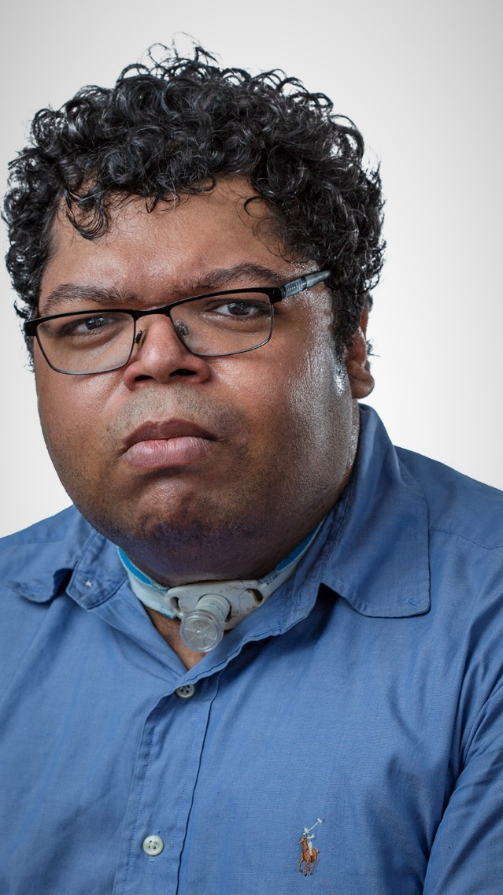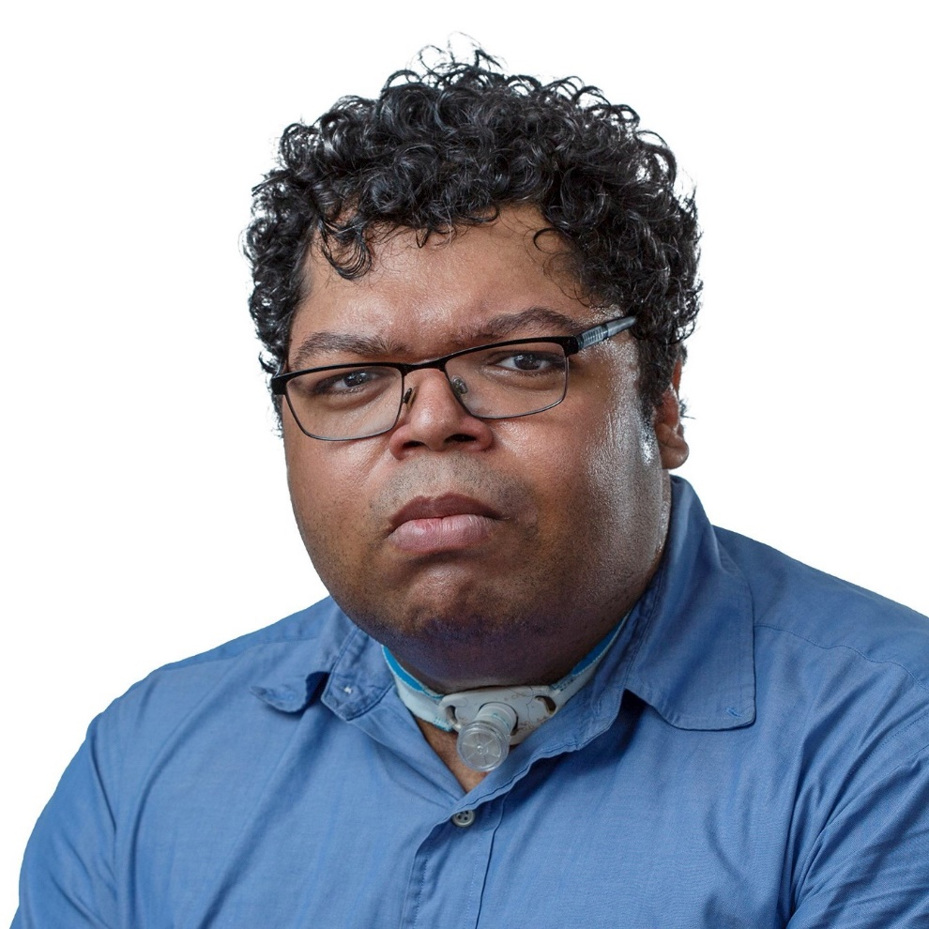

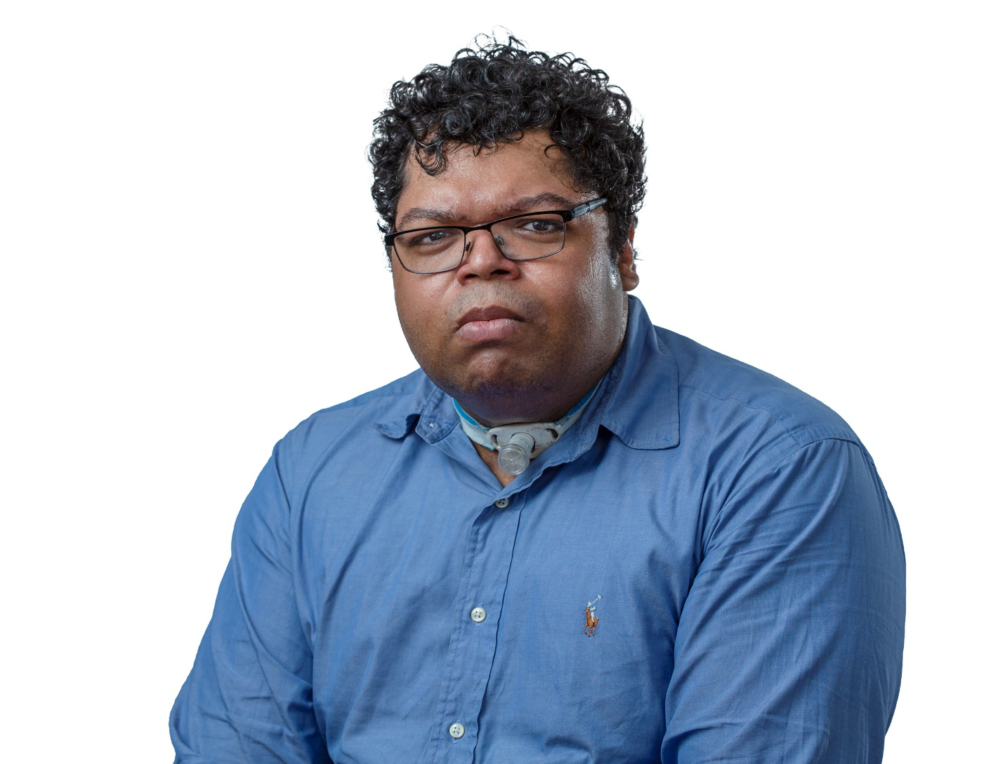

Cover
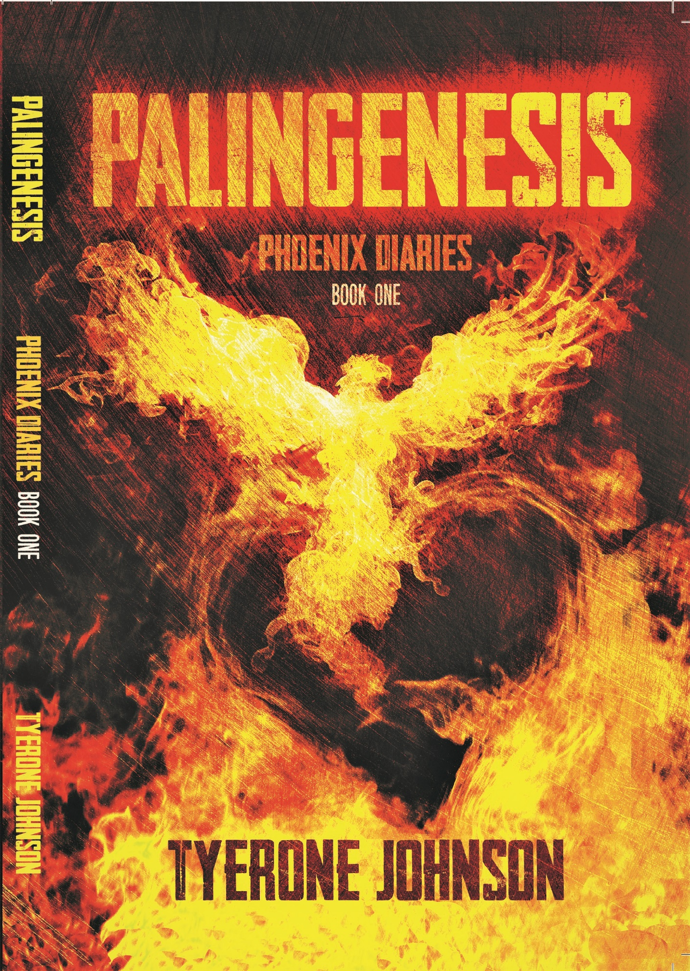

Sells Sheet

